

**Public hospital appointment**

**Project supervisor: Mohammed Abushariah**

|  |  |
| --- | --- |
| **0174637** | **Laila Nouman(leader)** |
| **0179313** | **Abedalrahman Hammad** |
| **0172966** | **Sarah Khriesat** |
| **0163753** | **Omar Al-Rantisi** |
| **0187803** | **Sara Jarrar** |
| **0187904** | **Asmaa Ayyoub** |

**1.0 Introduction**

1.1 Problem Definition …………………………………………………....3

1.2 Issues ………………………………………………………………….3

1.3 Project Aim & Objectives……………………………………………..3

1.4 Project Requirement …………………………………………………..3

1.5 Constraint …………………………………………………………..…4

**2.0 Feasibility Study**

2.1 Technical Feasibility………………………………………………………4

2.2 Economic Feasibility ……………………………………………………...5

**3.0 Human Information Requirements**

3.1 Identify System Stakeholders and Requirements Sources………………...6 3.2 Functional Requirement Definition………………………………………..6

3.3 Functional Requirement Specification…………………………………….8

3.4 Non Functional Requirements……………………………………………..8

3.5 Software and Hardware Requirements…………………………………….9

**4.0 System Analysis**

4.1 Context Diagram…………………………………………………………..10

4.2 Data Flow Diagram………………………………………………………..10

4.3 Entity Relationship Diagram………………………………………………11

4.4 Data Dictionary……………………………………………………………12

4.5 Structured Decision Analysis……………………………………………...13

4.6 System Proposal …………………………………………………………..13

**5.0 System Design**

5.1 Architecture Design………………………………………………………..14

5.2 Graphical User Interface Design…………………………………………..14

**6.0 System Implementation**

6.1 Graphical User Interface Implementation………………………………....20

**7.0 Conclusion**

1. **Introduction**

**1.1 Problem Definition**

Public hospitals face some challenges due to the unorganized process in delivering its services (consultation, pharmaceutical, surgical procedures … etc), overcrowding is one of them. It is the root of many problems such as wasting people (doctors and patients) time, excessive paper consumption and overwhelming the medical staff with many patients which might lead to wrong decisions.

Our project is an app to help patients, with insurance coverage, book appointments for consultation and order their prescribed medications. And also provide a way for the doctors to schedule for surgical procedures and other services. Automating this process will save time for both administrative staff and patients, and let doctors work in more efficient way.

**1.2 Issues**

* The flow of patients is very high and it does put stress on the traditional system.
* People are unaware in dealing with modern technologies which are not user-friendly.
* It takes a long time to book an appointment in public hospitals.
* People may get affected by viruses in public hospital especially nowadays.
* It may take effort to choose an appropriate date.
* It may become intertwined in dates.

**1.3 Project Aim & Objectives**

* Build a strong healthcare system.
* People use user-friendly application as easy as possible.
* Reducing waiting time.
* Reducing the chances of catching virus (Covid19).
* Decreasing the chances of mistakes when booking an appointment.

**1.4 Project Requirement**

* The app must be secured.
* The system must be easy to use by nontechnical users.
* The application must be reliable.

**1.5 Constraint**

* The website must be ready by 30th December.
* Development cost must not exceed 50,000$.

1. **Feasibility Study**
   1. **Technical** **Feasibility**

Our application has been developed by Android and will be used for smartphones that support Android system and IOS.

* Programming language: Using Java language and linking it to database.
* Hardware: Smartphone that use Android system or IOS.

|  |  |  |  |  |  |  |
| --- | --- | --- | --- | --- | --- | --- |
| **Cash flow** | **Year 0** | **Year 1** | **Year 2** | **Year 3** | **Year 4** | **Year 5** |
|  |  |  |  |  |  |  |
| **Development cost** | (3400) | 0 | 0 | 0 | 0 | 0 |
|  |  |  |  |  |  |  |
| **Operating cost** | 0 | (2800) | (3800) | (4800) | (5800) | (6800) |
|  |  |  |  |  |  |  |
| **Benefits** | 0 | 6000 | 7000 | 8000 | 9000 | 10000 |
|  |  |  |  |  |  |  |
| **Time adjusted cost** | (3400) | (2318) | (2934) | (3418) | (3791) | (4067) |
|  |  |  |  |  |  |  |
| **Time adjusted benefits** | 0 | 5455 | 5785 | 6010 | 6147 | 6209 |
|  |  |  |  |  |  |  |

|  |  |  |  |  |  |  |
| --- | --- | --- | --- | --- | --- | --- |
| **Cumulative time adjusted** | (3400) | (6818) | (9752) | (13170) | (16961) | (21028) |
| **cost** |  |  |  |  |  |  |
|  |  |  |  |  |  |  |
| **Cumulative time adjusted** | 0 | 5455 | 11240 | 17250 | 23397 | 29606 |
| **benefits** |  |  |  |  |  |  |
|  |  |  |  |  |  |  |
| **Cumulative time adjusted** | (3400) | (1363) | 1488 | 4080 | 6436 | 8578 |
| **(cost &benefits)** |  |  |  |  |  |  |
|  |  |  |  |  |  |  |

**Table (2.1): Payback analysis**

**2.2 Financial feasibility**

* **Payback Year** = the Fourth Year (Year 4).
* **Life Time ROI (Return On Investment)** = (Estimated Lifetime Benefits - Estimated Lifetime Cost)**/**Estimated Lifetime Cost

(29606–21028) / 21028 = 40%

* **Annual ROI** = Lifetime ROI / Lifetime of The System = 0.081

= 8%

* **Net Present Value (NPV)** = Cumulative Benefits - Cumulative Cost = 29606–21028 = 8578

**3.0 Human Information Requirements**

**3.1 Identify System Stakeholders and Requirements Sources**

Target users: Doctors who work at governmental hospitals, and patients who have governmental health insurance.

Requirement sources: Booking appointments (first time & follow up), scheduling surgical operations, getting prescriptions.

**3.2 Functional Requirement Definition (user requirements)**

3.2.1 Patients

3.2.1.1 Sign Up

Patients create an account by filling in information about their national ID or health record number, and they choose a username and a password. This account will be used to access the application.

3.2.1.2 Login

Patients who already registered will use their username and password to access their account.

3.2.1.3 Upload necessary documents

Patients enter any necessary files of their documents and cards to be saved into the system, and linked to their accounts, without repeating this process every time. According to the documents, the hospital that covers their insurance would be added to their profile.

3.2.1.4 Request an appointment

Appointments can be made by patients through filling a simple form about the physician specialty they require, date and time they want.

3.2.1.5 Display physicians calendars to the patients

This allows the patients to check for available appointment times on the doctors calendars and to book them, and it will be constantly updated according to patients reservations by adding the request number. Also, the reservation will be added to the patients calendar.

3.2.1.6 Show the personal calendar (future enhancement)

Patients can add their reminders for their appointments beforehand so they won’t forget or miss it.

Logout (future enhancement) 3.2.1.7

Patients sign out from their accounts.

3.2.2 Doctors

All doctors have accounts that can be accessed through usernames and passwords that we sent by email, and can see a unified table for available OR, radiology rooms.

3.2.2.1 Log in

Doctors can login by their association number.

3.2.2.2 Display and update calendar

Doctors can see bookings.

3.2.2.3 Request a surgical operations and images

Doctors can reserve an OR in the hospital if the patient needed any surgical intervention, or needed any type of images (XRAYS, MRE, etc..). Patients name will be used for reservations. Timing will be updated on the related patients calendar as well.

3.2.2.4 Enter prescriptions

Doctors can add medication info to related patients if needed so pharmacist can approve patients medications requests.

3.2.3 Pharmacist

All pharmacists have accounts that can be accessed through usernames and passwords that we sent by email.

3.2.3.1 Show prescriptions.

Pharmacist can see uploaded prescriptions.

3.2.3.2 Mark prescription as given

**3.3 Functional Requirement Specification**

* Business Rules:

Patients: The system should be able to allow users to register by entering a username and password, confirming the password, age, gender, region, and phone number, and then verifying the registration by sending a message to the user with a code to confirm the registration process. The option to add an appointment allows the user to book an appointment, but before that it will check whether the appointment is still available. The cancel appointment option will allow you to cancel the appointment. This interaction will delete appointment information from the database.

Doctors: Can reserve rooms and appointments for required services and check their calendars, and they can add details of patients medications if needed.

Pharmacists: Can check entered prescriptions to approve patients requests.

* Administrative functions: An admin, which in our case is us, will add doctors association numbers and help maintaining the app.
* Authentication and authorization frameworks would be used to secure both patients and doctors.
* Image processing libraries should be used to validate documents.

**3.4 Non Functional Requirements**

* Usability: The system will have a good user experience and interface to make it easy to use for non techies.
* Availability: The system will be up and we will maintain it.
* Accessibility: The System is accessible once the user downloads the application from the application store.
* Security: A security layer will be added to keep all sensitive patients/doctors information’s private.
* Performance: The system will be fast and responsive through using appropriate libraries and following best coding practices.

**3.5 Software and Hardware Requirements**

**Software requirement:**

|  |  |
| --- | --- |
| **Requirement** | **Software** |
| Android 9/ IOS 9 or higher. | Operating system |
| Eclipse, Netbeans, Notepad ++ | Development Tools |
| Apache Server 1.7.1 or Higher included MySQL | SQL Server |

**Hardware requirement:**

|  |  |
| --- | --- |
| **Requirement** | **Hardware** |
| IPhone/ Samsung/ Sony/ Huawei | Smartphone |
| A4/ Exynos 7 Dual/ MediaTek Helio A/ Kirin | Processor |
| 16 GB | Memory (RAM) |

**4.0 System Analysis**

**4.1 Context Diagram**

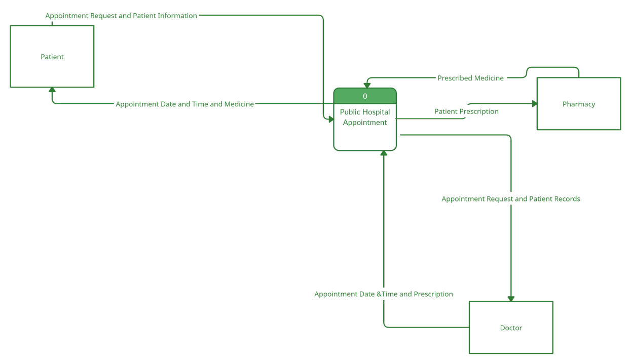

**4.2 Data Flow Diagram**

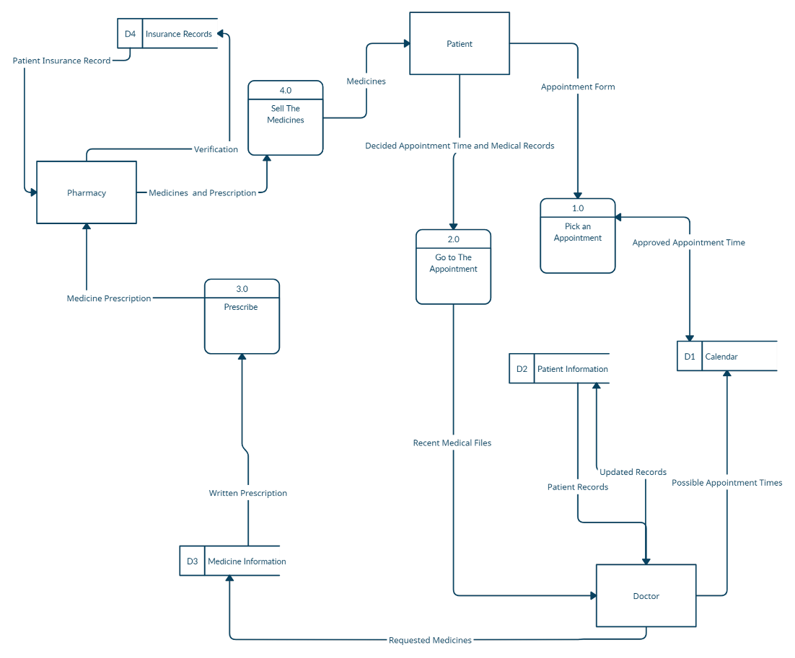

**4.3 Entity Relationship Diagram**

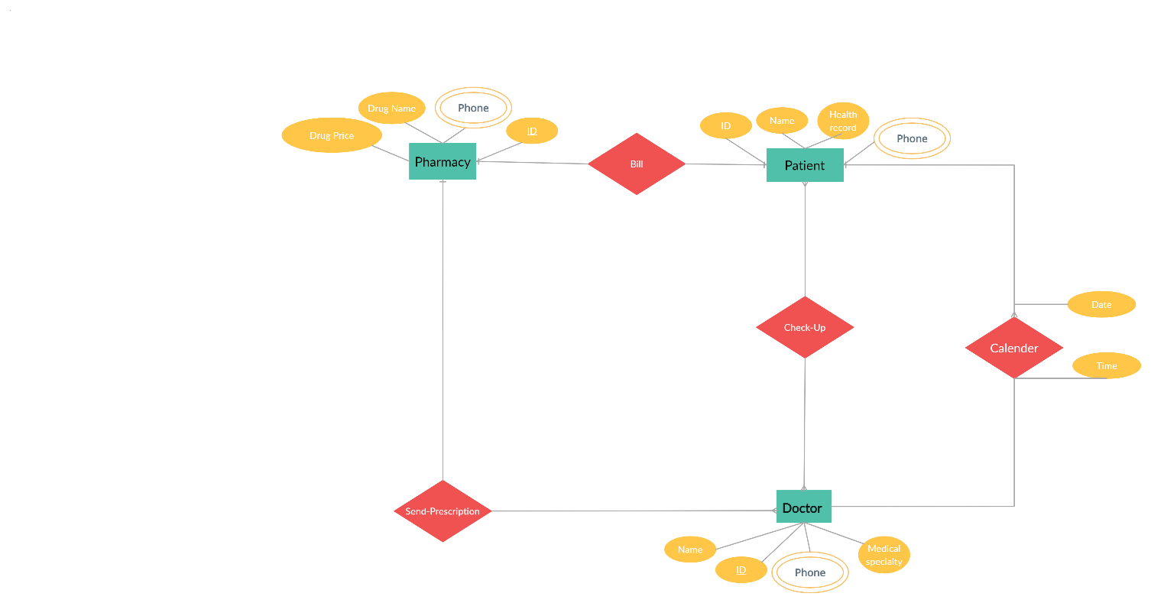

**4.4 Data Dictionary**



**4.5 Structured Decision Analysis**

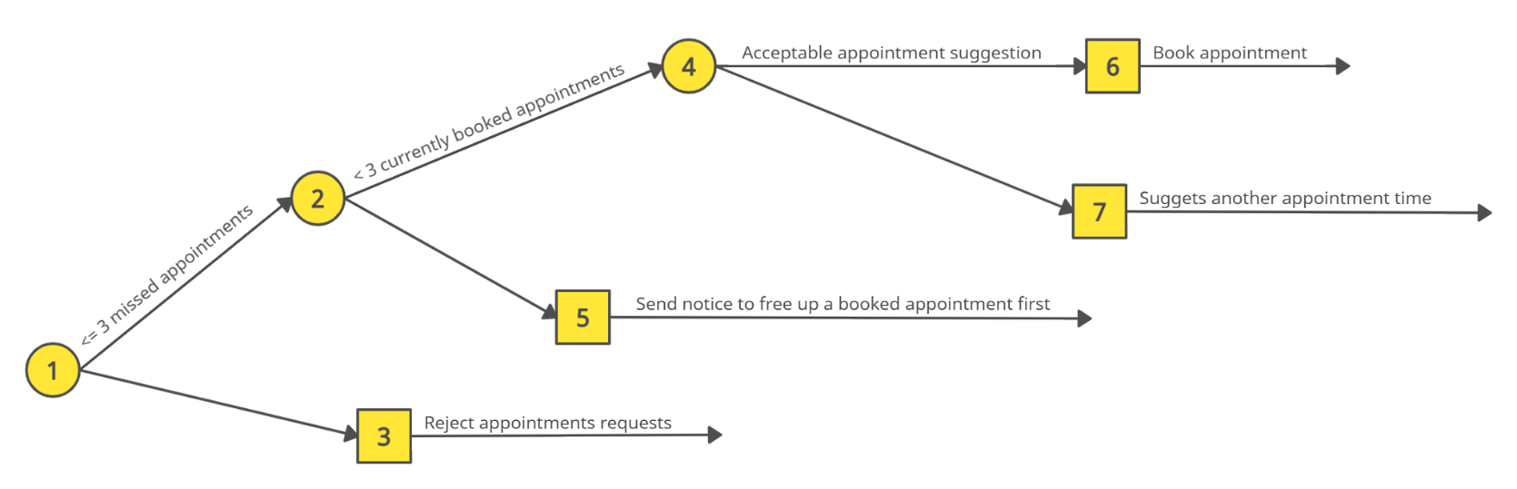

**4.6 System Proposal**

Saving time and effort is what we are trying to achieve, organizing the process of booking appointments, rooms and services can grantee that for patients who have insurance, doctors and pharmacists working in public hospitals, many features can be added in the future to help improve the healthcare system in Jordan. Our project can be considered as a prototype of healthcare management system.

**5.0 System Design**

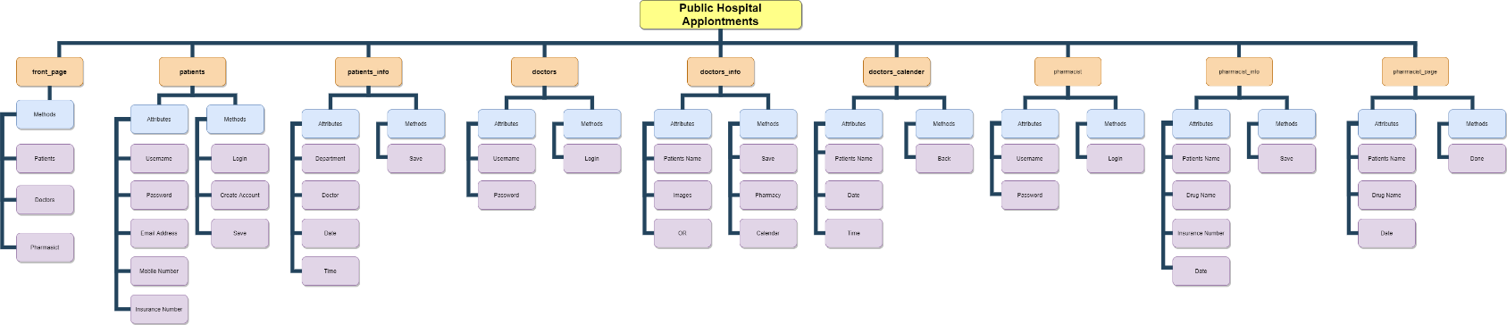**5.1 Architecture Design**

**5.2 Graphical User Interface Design**

**Login Page**

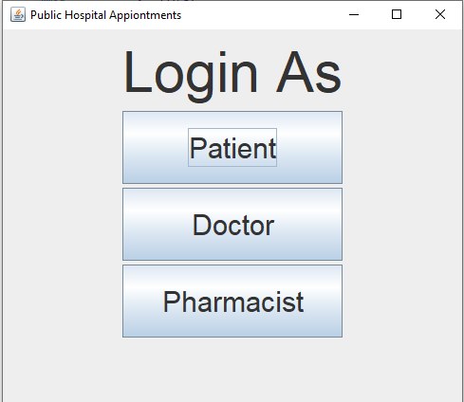

**Patients Login**

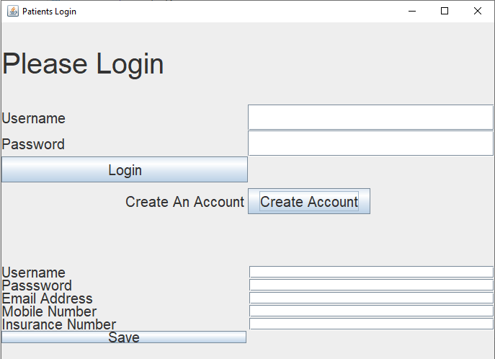

**Appointment Page: (Patient can choose department, doctor, date and time)**

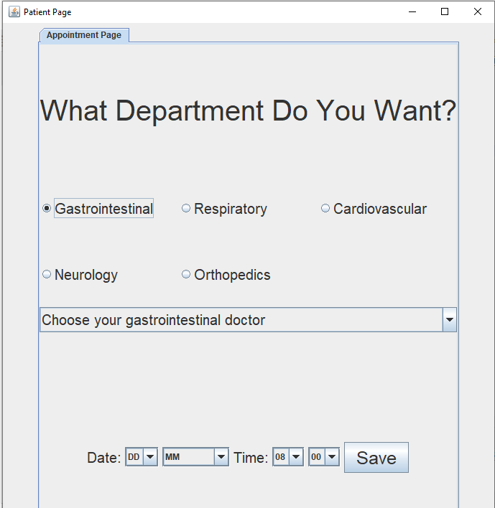

**Doctors Login: (Doctors info should be saved in database and credentials are sent via email, no need for sign up)**

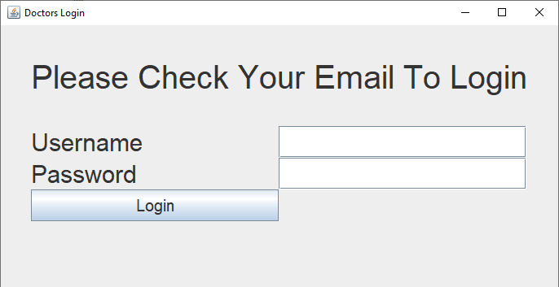

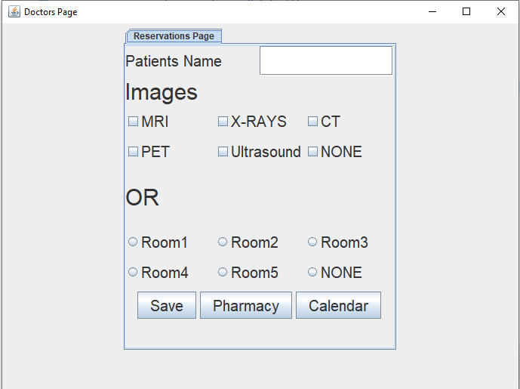**Doctors Page: (Doctors can book services and a room if needed, and click on pharmacy or calendar buttons)**

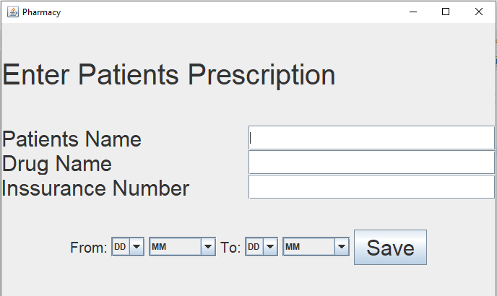**Pharmacy Page: (Doctors can enter details of a patients medication when needed so pharmacist can check it)**

**Doctors Calendar: (Doctors can check patients reservations)** 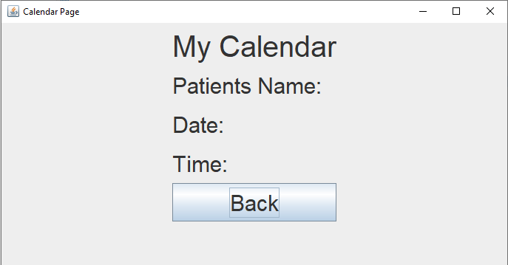

**Pharmacist Login: (Pharmacist info should be saved in database and credentials are sent via email, no need for sign up)**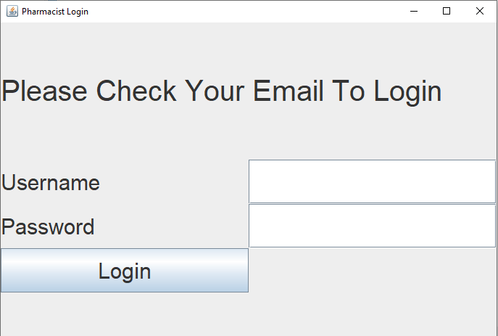

**Pharmacist Page: (Pharmacist can see prescriptions entered by doctors)**

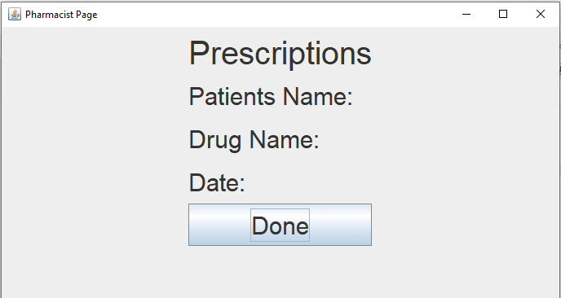

**6.0 System Implementation**

**6.1 Graphical User Interface Implementation**

**front_page**

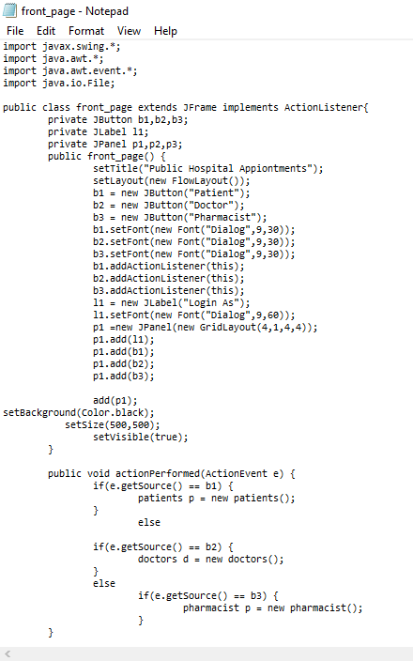

**patients**

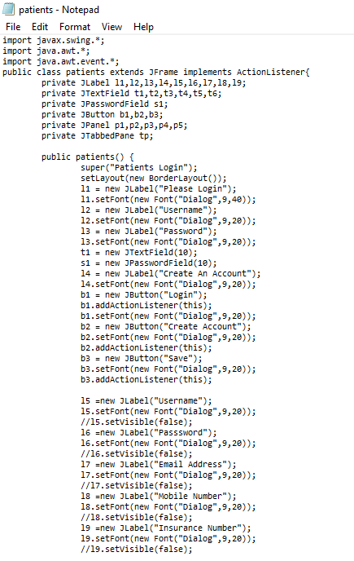

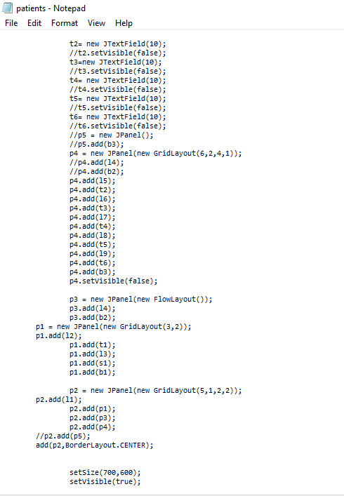

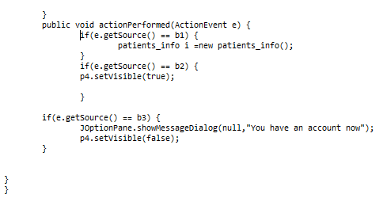

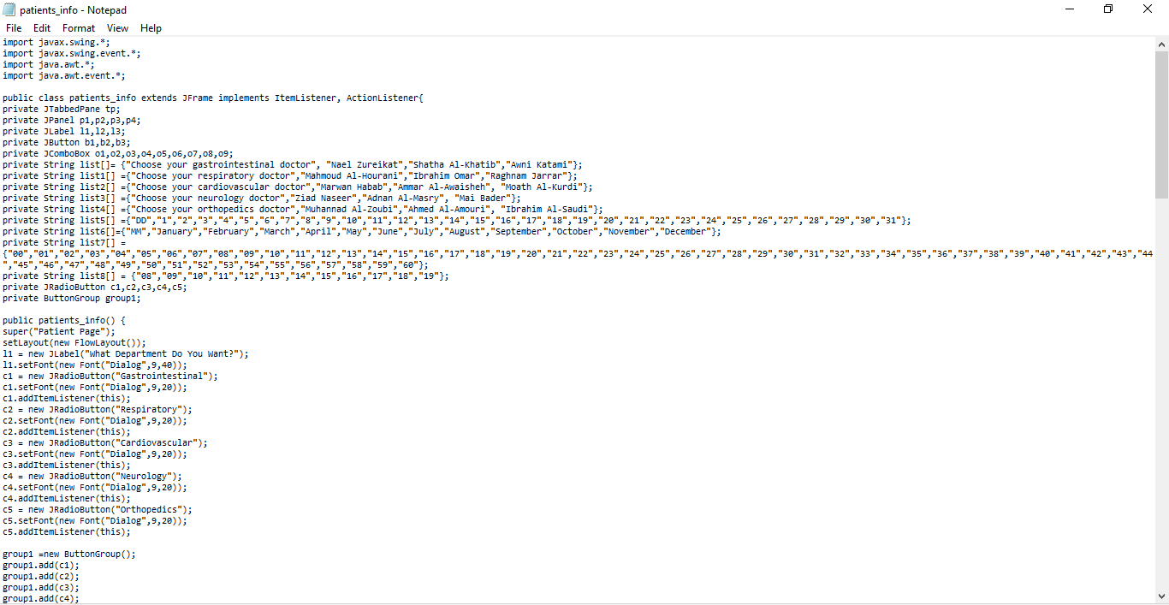**Patients_info**

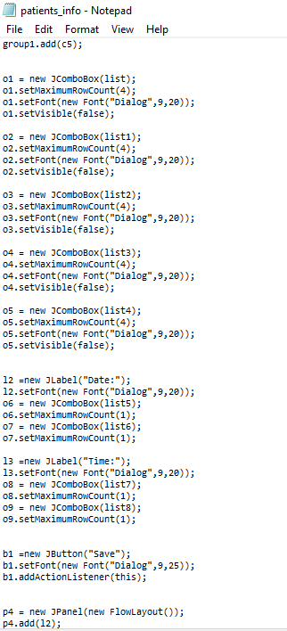

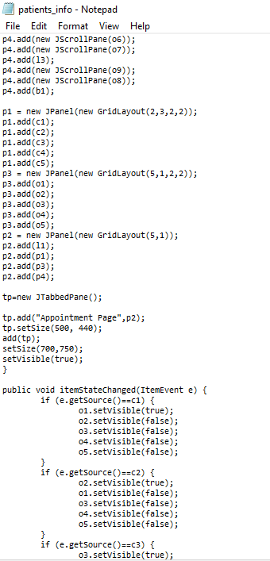

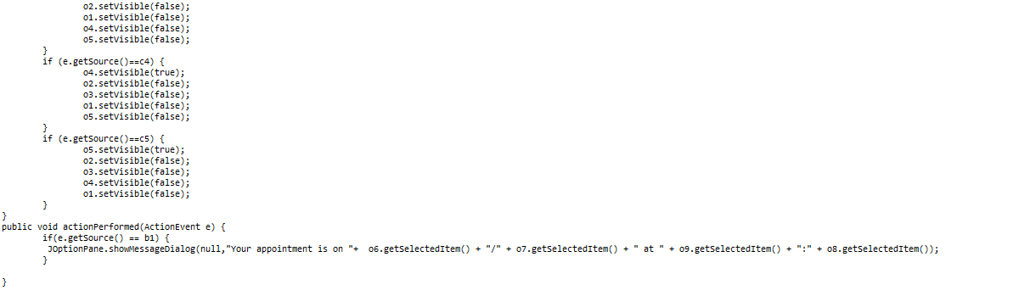

**doctors**

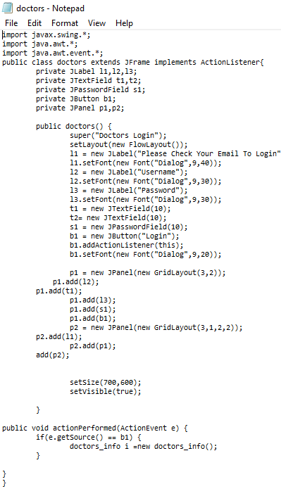

**doctors_info**

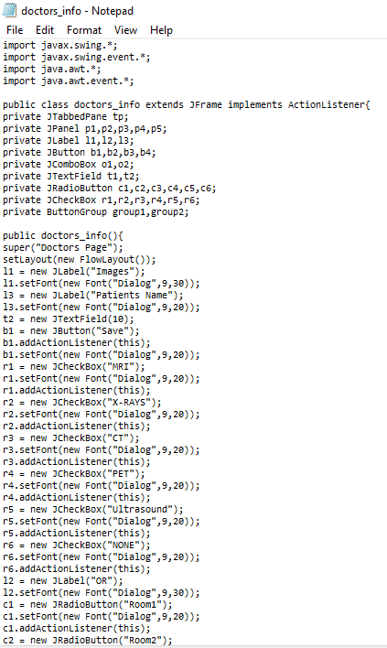

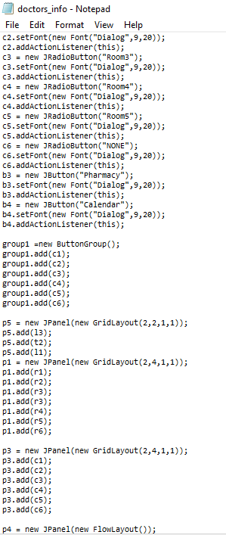

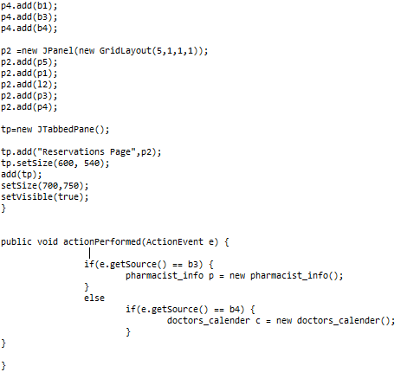

**doctors_calender**

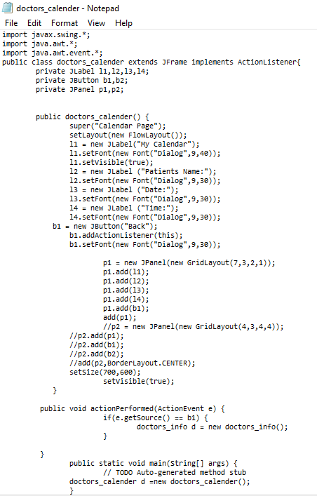

**pharmacist**

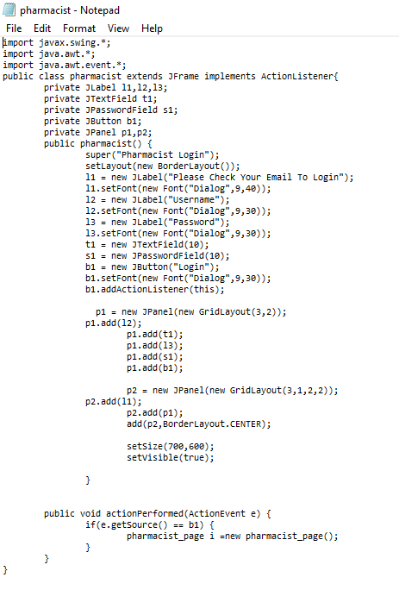

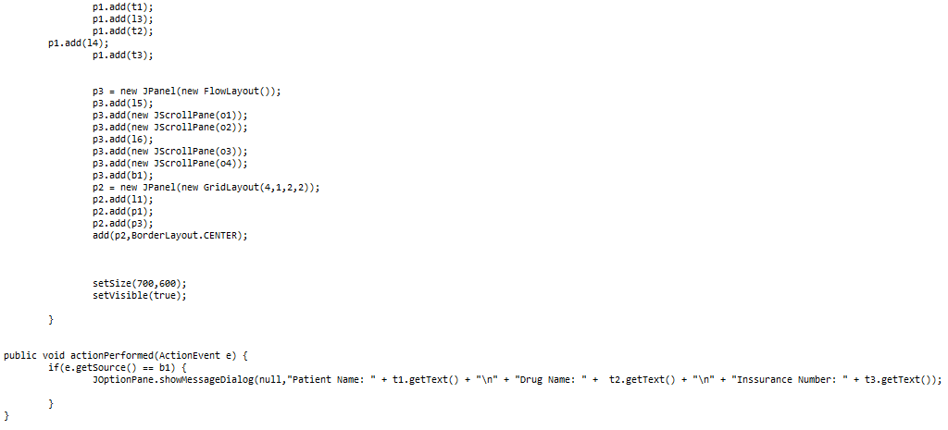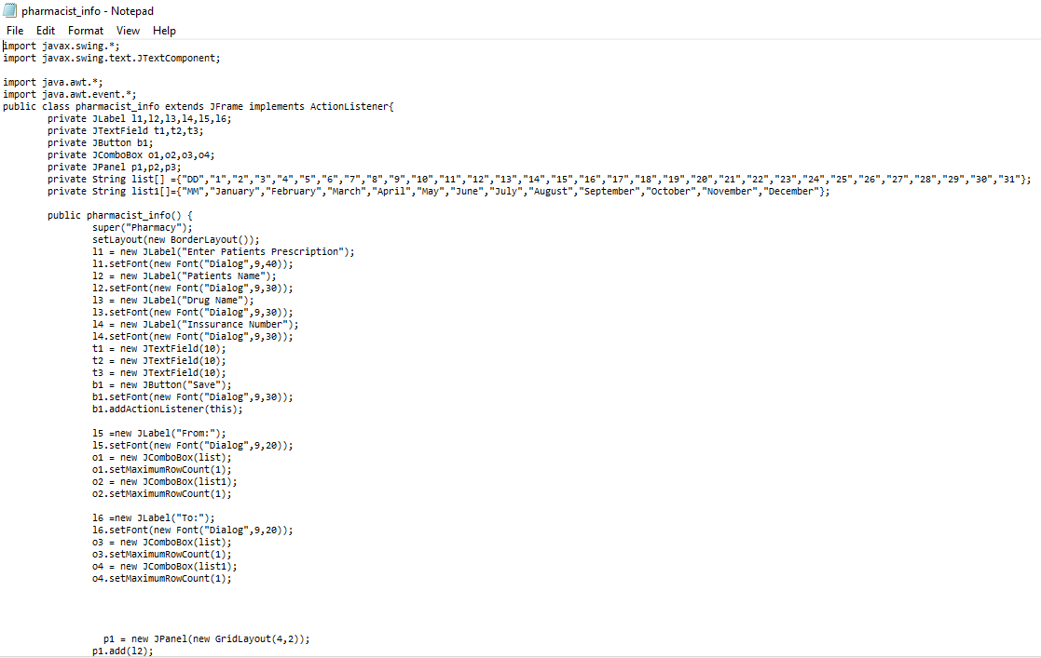**pharmacist_info**

**pharmacist_page**

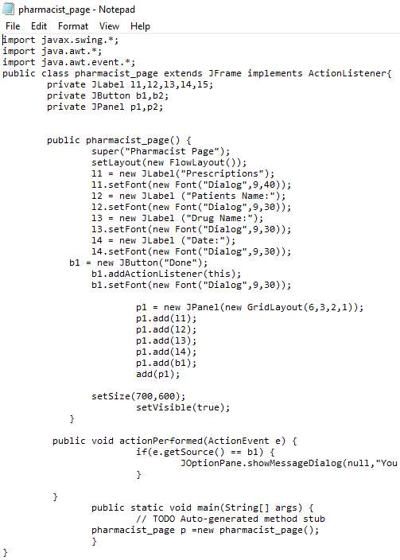

**7.0 Conclusion**

Our product can ease the process of booking appointments, taking prescribe medicines, reserving rooms in the public health sector. Therefore it will improve the health system in our beloved Jordan. Many enhancements and features will be added in the future to make it more complete. We welcome any suggestions and there is always a space for enhancements.